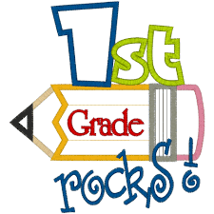
Ms. Moffett’s supply list
2018-2019
Bring to Meet and Greet
*Please do not label supplies with your child’s name
- 24 pack of #2 sharpened pencils
- 1-flat eraser
- 1-small (snap close) plastic pencil box (about 8x5.5)
- 3- large glue sticks
- 1-pair of Fiskars kid scissors
- 2-boxes of 24 count regular Crayola crayons
- 3-plastic pocket folders with brads (1 red, 1 green, 1 yellow)
- 3-Wide ruled composition books (100 sheets)
- 2-spiral notebooks (70 sheets)
- 1-box of regular sized tissues
- 1-box of skinny Crayola markers
- 1-pack of Expo Dry Erase markers (black)
- 1-1/2 inch white binder with clear front sleeve
Optional: set of headphones that your child will keep in their book box for I pad and computer use in the classroom

Girls Boys
*Gallon sized Ziploc bags *Sandwich sized Ziploc bags
*1-container of Wet Ones wipes *1-container of hand sanitizer

